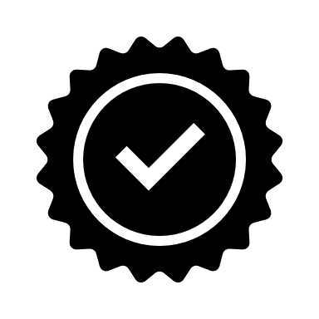
Have you remembered to get approval?
Use this checklist if you process personal data in your research.

Do I need to apply for approval?
If all three of these conditions apply to you, you must remember to get approval from the Danish Data Protection Agency before you share personal data.
1. I am sharing sensitive personal data and/or data about criminal offences.
2. I am sharing personal data using scientific research purposes as a legal basis for processing the data (Section 10 of the Danish Data Protection Act)
3. The data being shared (here you only need to answer ‘yes’ to one of the options):
a. is being shared with a data controller outside the EU/EEA
b. is in the form of biological material (e.g. tissue or blood)
c. will be published in a recognised scientific journal or equivalent publication (e.g. a data repository)

Where can I get help?
Unsure about anything? Contact the Data Protection Office at AU at fortegnelse@au.dk

