Mail merge of butterfly nametags
- Open the Excel file that you wish to merge from and ensure that all columns have the correct headlines for the nametags. If you have not created this row yet, please do and name the first row as seen below. This is a necessary step; otherwise, Word will interpret the top row as the name of the column and not as a name for a badge.
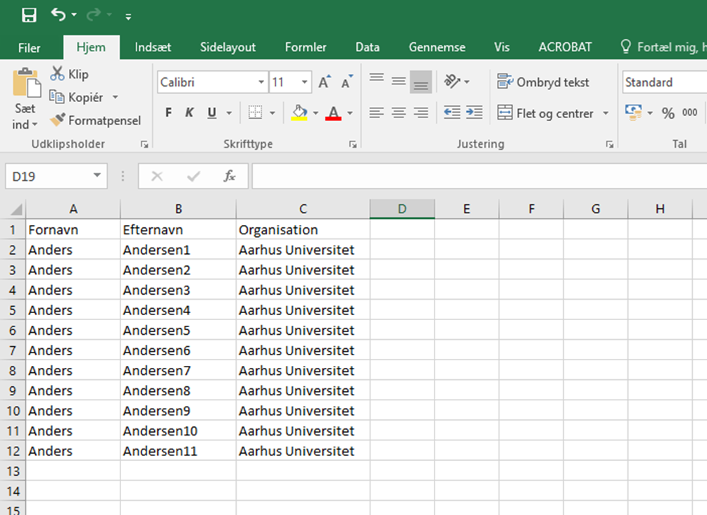
Example: Fornavn (First name) Efternavn (Surname) Organisation (Organisation)

- Save your Excel file.

- Find the file named “Template for nametags – butterfly nametags” and download it. (The template can be found via this link Name tags and templates (au.dk))

- Open the template.
Click on the “Mailings” tab.
Choose “Start Mail Merge” and the click on “Step-by-step Mail Merge Wizard”

- Next, the mail merge window will appear on the right side of your screen. Please let document type remain as “Letters”.

- Click “Next: Starting document”.
Select “Use the current document”.

- Click “Next: Select recipients”.

- Select “Use an existing list” and then click on “Browse” to find the Excel file you have created with the participants’ names in it.
Click “Open”.
- If a window pops up with “Choose data” (depends on which edition of Excel/Word is installed on the PC), click “OK” for the marked sheet or data.

- After choosing your data (the names and information), a new window will appear. Here you can see each row from your Excel file. Click “OK”.
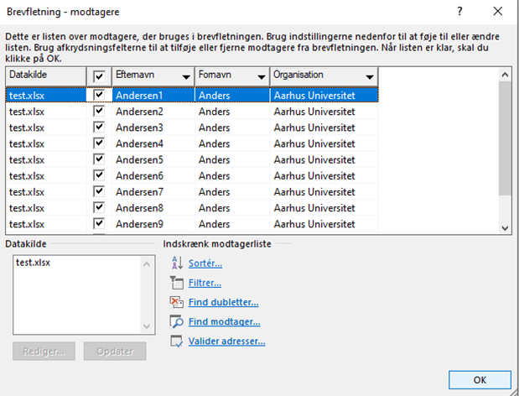

- Click “Next: Write your letter”

- Mark the top <<Fornavn>> (without marking the chevrons: “<<” + “>>”) and click on “More items” on the right side of the screen. Choose the name corresponding to the one you marked before.

In the example, it would be “Fornavn”.

- Click “Insert” and close the window afterwards.

- Click “Next: Preview your letters”. Now the names should be the same as in the Excel file.

- Click “Next: Complete the merge”.

Please note that every name should appear twice so that every page only has three different names. When the document is printed, the nametags will be folded over.
We recommend doing a test and only printing the first page before printing the entire document. After the test, you can see whether you are using the correct tray and have turned the paper correctly. Remember to place the right amount of butterfly sheets in the printing tray.
When you are ready to print:
- Choose “Print” in the mail merge column. If a window pops us, just click on “OK” for “All”.

- Print away!

- Afterwards, fold all the nametags so that the same name appears on both sides. The butterfly badges are adhesive.
See the pictures below for an example of a correctly folded butterfly nametag!

