Title of the Work Flow (?): Overwrite with title

Link to method procedure (?): Insert any link to the method procedure/ protocol/SOP etc..
General Safety information: | 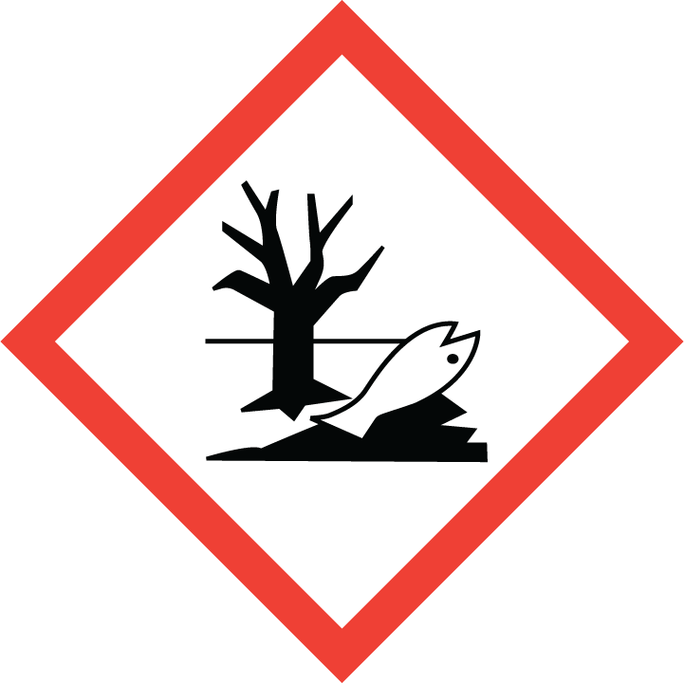  This information is retrieved from Kiros (HE standard texts):  - Place of use.  - Use -application.  - Specific local safety measures.  - Placement and us of protective equipment.  - Placement and use of first aid equipment.  - Fire extinguishing equipment.  - Emergency telephone number.  - Disposal of hazardous and regular waste.  - Name of contact person regarding hazardous waste.  - Storage.  - Internal transport.
General Safety information: | Or refer to an internal safety instruction, guide or similar.
Safety data sheets used in the workflow: | Get data from Kiros or list the hazardous chemicals with name, hazard pictograms and H-phrase(s).
Identification of dangerous steps and preventive measures:

Workflow/Chemical | Risks/Dangers: | Impact/Degree of exposure: | Preventive measures: | Other:
Describe the dangerous step in the workflow or describe the chemical | Describe the risks and dangers of exposure. | Describe the duration in time and the quantity/amount. | Describe the effective preventive measures and personal protective equipment | Describe other things to be aware of in relation to the risk
Overall assesment: | Make an overall assessment and describe this.  Are the employee/student safe?
Action plan  (if necesarry): | If an action must be taken before the workflow is completely safe, this is described.  If the workflow is safe, do not write anything in this box.
Links or other: | Insert links or attachments.
Last updated: | Date: | Write the date | Initials: | Write your initials

