THE LAST EXPERIENCE GATHERING SESSION
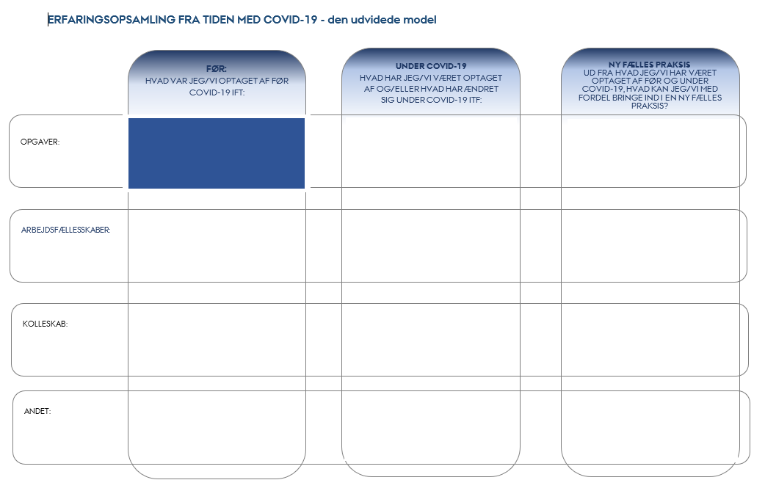 | - TASKS: In the last experience gathering session – what were we focused on bringing forward into the new common practice in relation to tasks (core task related, administrative and strategic)?
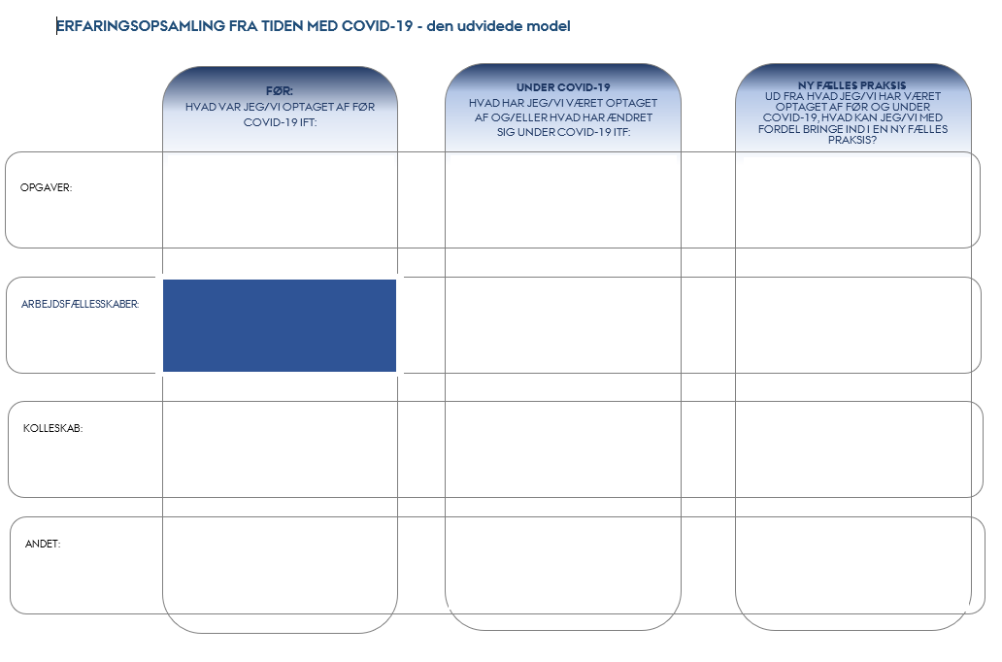 | - COLLABORATIVE COMMUNITIES: In the last experience gathering session – what did you/we wish to bring into the new common practice in relation to the communities?
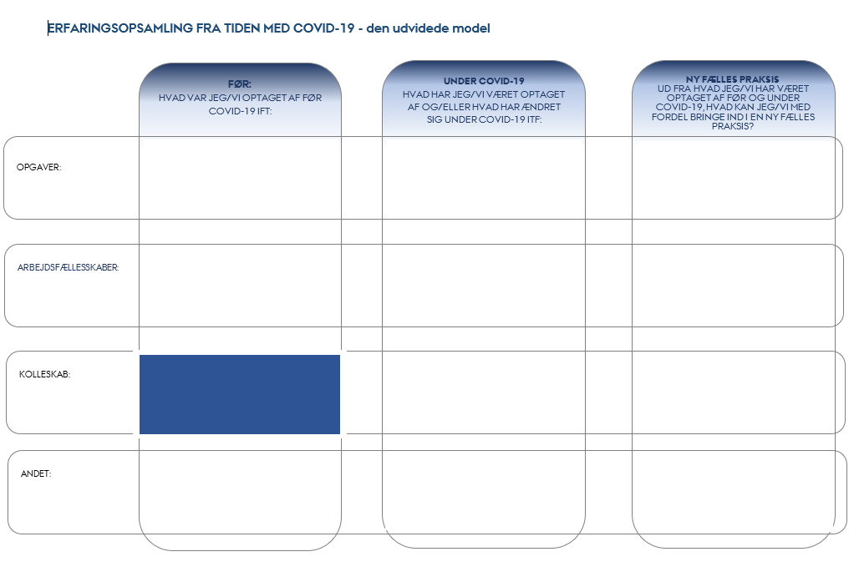 | - COLLEGIAL RELATIONSHIPS: In the last experience gathering session – what did you/we wish to bring into the new common practice in relation to collegial relationships?
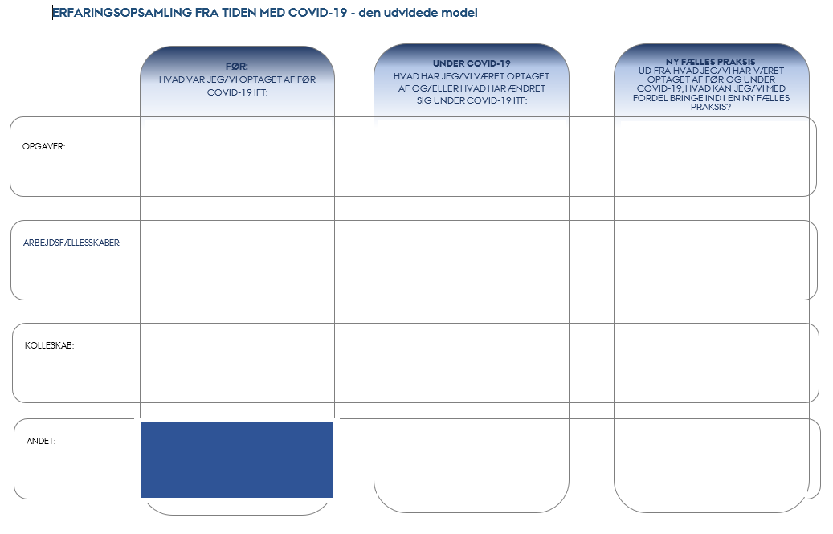 | - OTHER: In the last experience gathering session – what did we wish to pay attention to going forward in relation to strengthening well-being?
DURING THE RECENT PERIOD WITH COVID-19
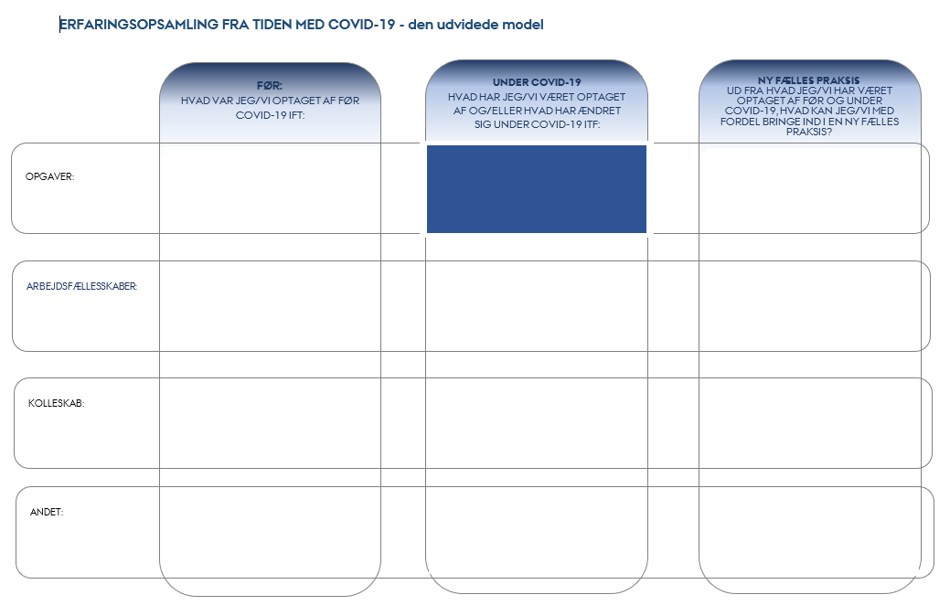 | - TASKS: What have you/we focused on during the recent period with Covid-19 in relation to tasks (core task related, administrative and strategic)? What has been challenging in relation to task performance and what experiences have you gathered?
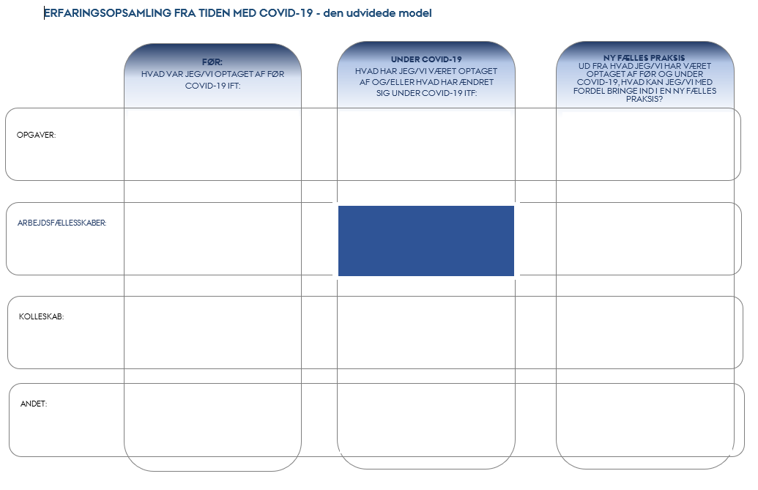 | - COLLABORATIVE COMMUNITIES: How have the collaborative communities been working recently? What has been challenging in relation to being part of collaborative communities, and what have we learnt and?
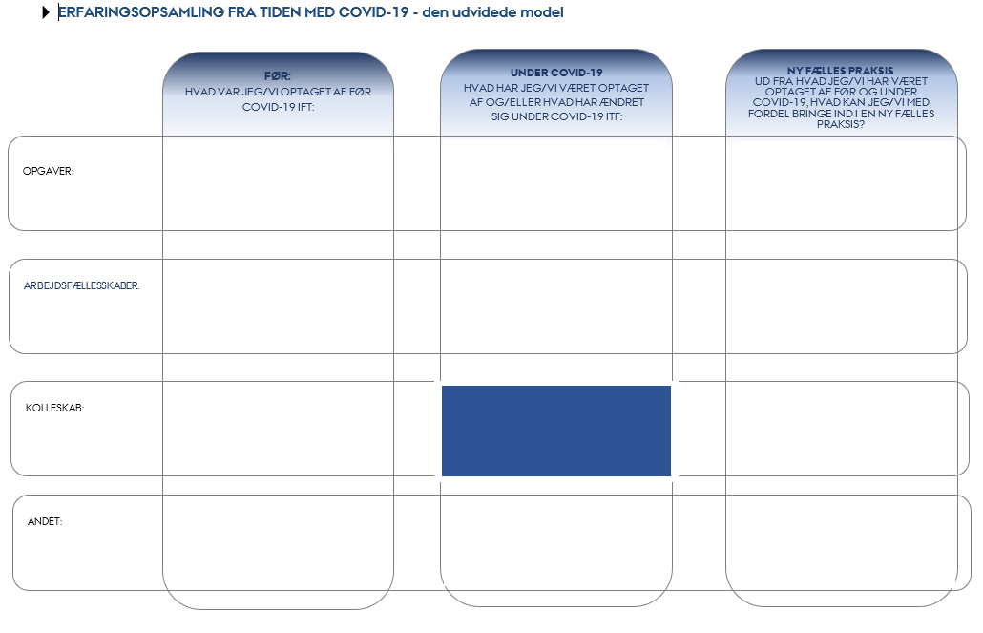 | - COLLEGIAL RELATIONSHIPS: What have we been focused on in relation to collegial relationships during the recent period with Covid-19? What has been particularly important for us and what was not really important?
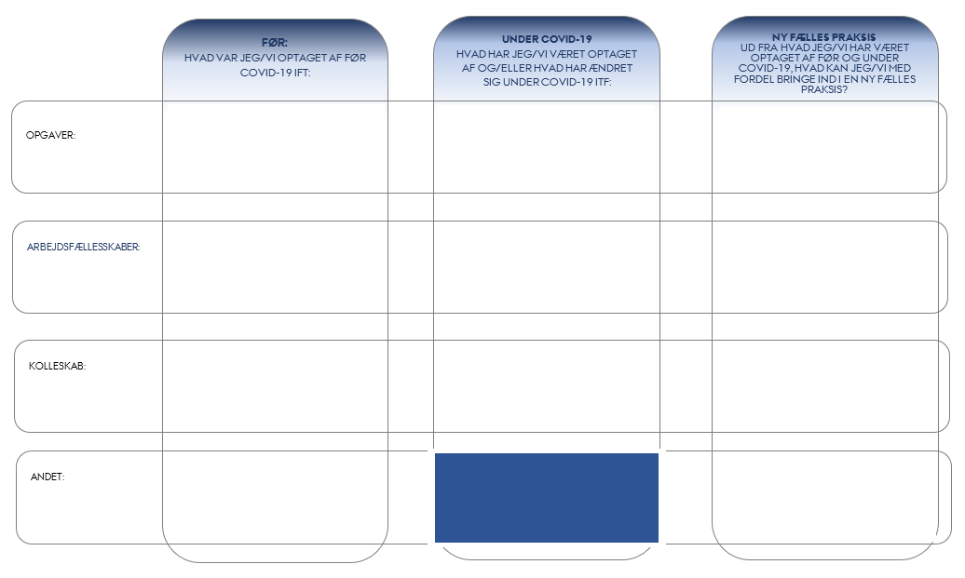 | - OTHER: How have we been feeling physically and mentally during the recent period with Covid-19? What has worked well and what has been difficult?

NEW COMMON PRACTICE
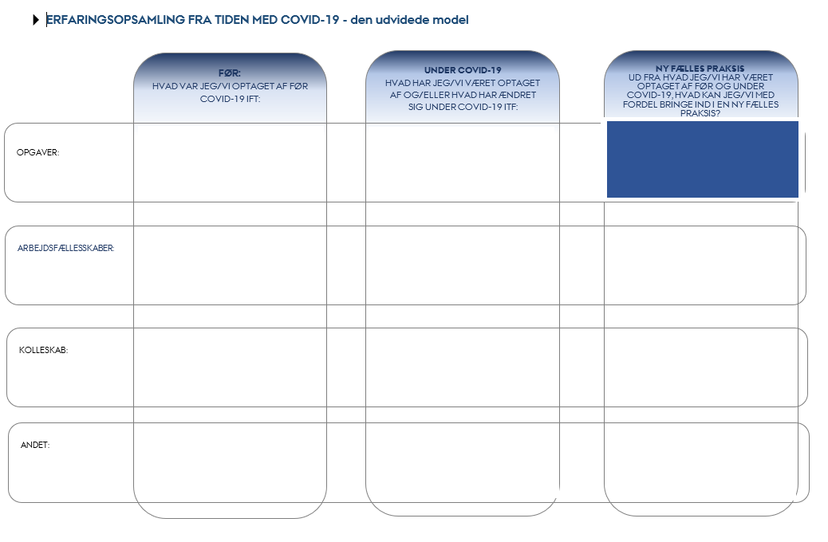 | - TASKS: Based on the experiences we have gathered now, what should we bring into the coming period in relation to tasks (core task related, administrative and strategic)?
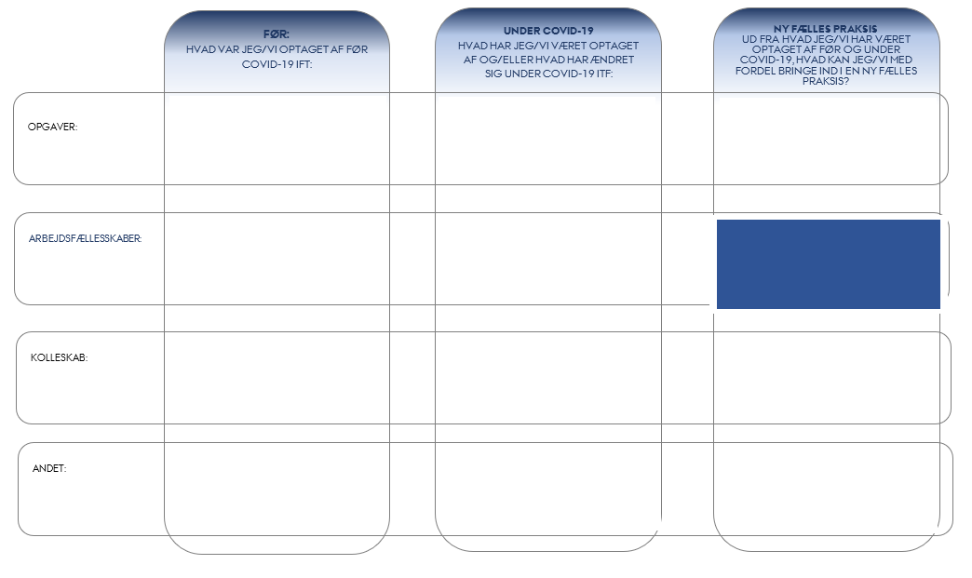 | - COLLABORATIVE COMMUNITIES: Based on the experiences we have gathered now, what should we bring into the coming period in relation to collaborative communities? What should we keep doing and what should we put behind us?
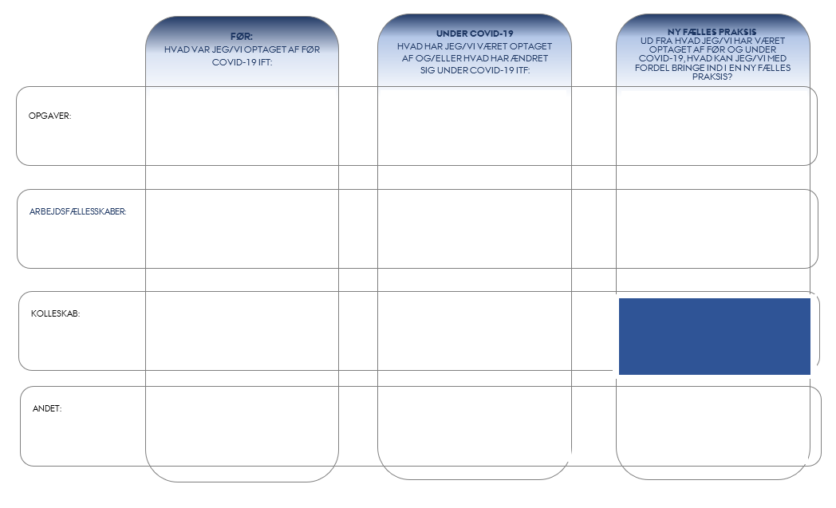 | - COLLEGIAL RELATIONSHIPS: Based on the experiences we have gathered now, what should we bring into the coming period in relation to collegial relationships? What should we all be aware of in relation to, for example, online meetings, working from home, etc.?
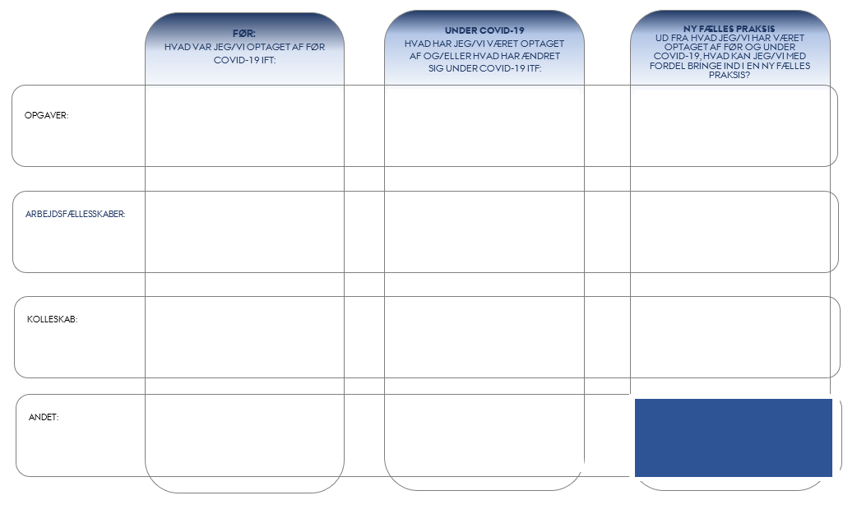 | - OTHER: Based on the experiences we have gathered now, what should we bring into the coming period in relation to creating a safe workday characterised by well-being for all of us? Do we have any concerns in relation to psychological, physical or practical matters in connection with the reopening phase that we should take into account during the planning phase? What is particularly important for us individually and as a group to be aware of?

