DURING COVID-19
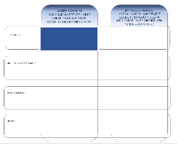 | - TASKS: What have you/we been focused on during Covid-19 in relation to tasks (core task related, administrative and strategic)? What has been challenging in relation to task performance and what experiences have you gathered?
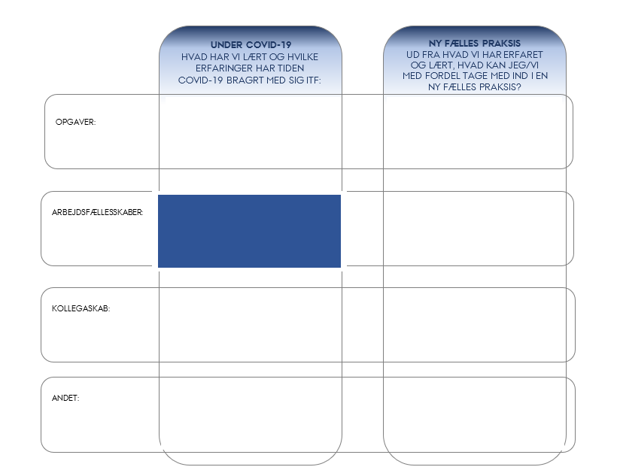 | - COLLABORATIVE COMMUNITIES: How have the collaborative communities been working during Covid-19? What has been challenging in relation to being part of collaborative communities, and what have you/we learnt?
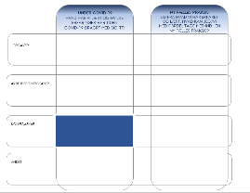 | - COLLEGIAL RELATIONSHIPS: What have you/we been focused on in relation to collegial relationships during Covid-19? What has been particularly important to you/us and what was not really important?
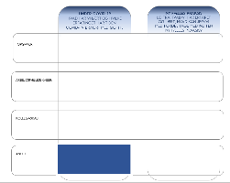 | - OTHER: How have you/we been doing physically and mentally during Covid-19? What has worked well and what has been difficult?

NEW COMMON PRACTICE
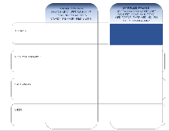 | - TASKS: Based on your/our experiences and considerations during Covid-19, what do you/we need to be aware of in the future in relation to tasks (core task related, administrative and strategic)?
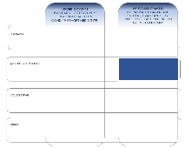 | - COLLABORATIVE COMMUNITIES: Based on your/our focus areas and considerations during Covid-19, what should you/we pay particular attention to in the future in relation to collaborative communities? What should you/we keep doing and what should you/we put behind you/us?
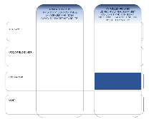 | - COLLEGIAL RELATIONSHIPS: Based on your focus areas and considerations during Covid-19, what do you wish to bring with you into collegial relationships in the future? What should we all be aware of in relation to, for example, online meetings, working from home, etc.?
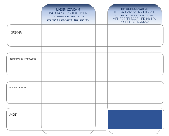 | - OTHER: Based on where you/we are now, what is needed in order to create a safe workday characterised by well-being for you/us? Do you/we have any concerns in relation to psychological, physical or practical matters in connection with the reopening phase that we should take into account during the planning phase? What is particularly important for you as individuals and as a group to be aware of?

