How to log in to Emply Hire for the first time
For HR staff: Complete the fields marked in red with the relevant data before sending the guide to the recipient.

The first time you log in to Emply Hire to access application material for a position, you must create a password. This guide can also be used if you have forgotten your password. Follow the steps below:

- Go to https://adgang.au.dk/en/password/forgot
- Enter your private e-mail [INDSÆT MAILADRESSE SOM ANGIVET UNDER “PRIVATE KONTAKTOPLYSNINGER” I MEDARBEJDERSTAMKORTET] and press next.
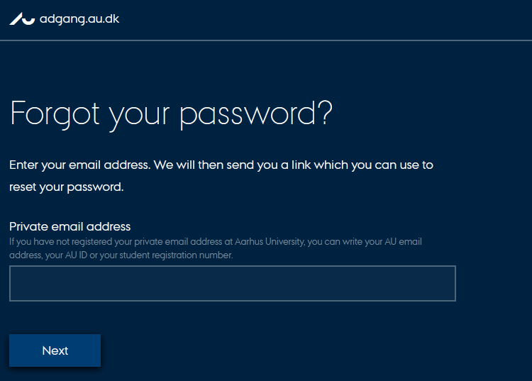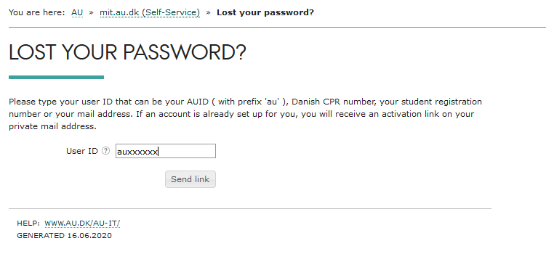
- Check your email for this email address: [INSERT EMAIL ADDRESS AS STATED UNDER "PRIVATE CONTACT INFORMATION IN MEDARBEJDERSTAMKORTET (THE EMPLOYEE REGISTRATION SYSTEM)]
NOTE: This is a no-reply email from Aarhus University. It may end up in your spam filter.
- Click on the link in the email to create your password. Now create a new password which follows the Aarhus University standards for passwords.

A password must contain at least 12 characters with combinations from at least three of the following categories:
- Upper-case letter (A-Z)
- Lower-case letter (a-z)
- Number
NOTE!
- You cannot use æ ø å Æ Ø Å
- You cannot use a password previously used for an AU system.
- A password should not contain personal information and must not contain parts of your name.

- Now we will make sure that you have created a correct password. Therefore, we will ask you to log on to mit.au.dk
- Go to www.mit.au.dk - for English click "English"
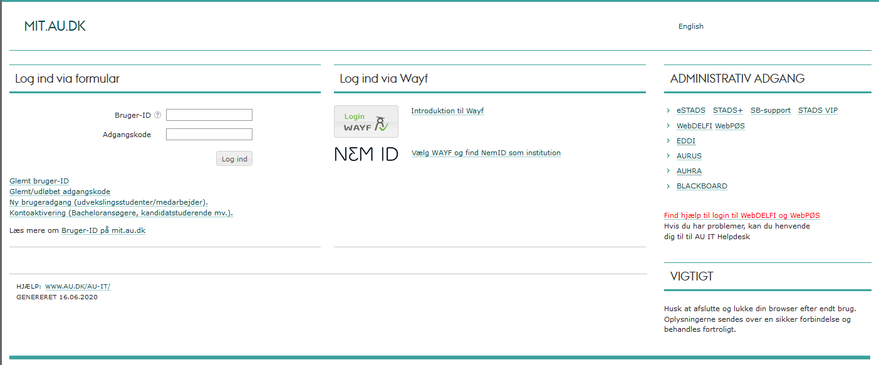

- Enter "au[ENTER AU ID] as your "User ID" and your newly created password in "Password"
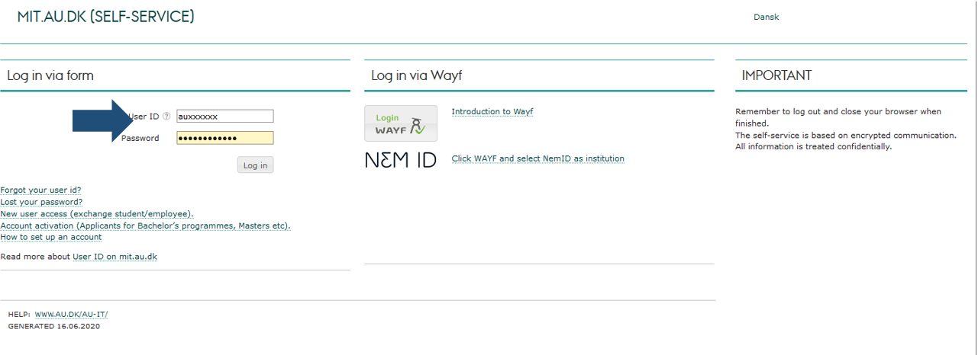
If you can log in without any problems, then proceed to the next step. Please note that this page does not allow you to access the applicants' material, including their CVs and applications.

If you are unable to log in to mit.au.dk, please repeat steps 1-7 with a new password. If you need help, please call us on [INSERT telephone no.] between [INSERT LOCAL TIME] and [INSERT LOCAL TIME].
For security reasons, we cannot manually give you a password.

- Go to au.emply.net (no www. in front)
- Insert the following:
In the first box: au[INSERT AU ID NO.]@uni.au.dk
In the second box: Your new password, with which you can access mit.au.dk.
Click on “Log in”
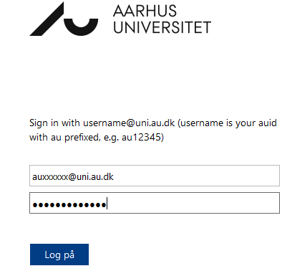

- You now have access to the applicants' CVs, applications and other material. Click on the name of the position.

To change the language setup in Emply, see the guide www.medarbejdere.au.dk/fileadmin/www.medarbejdere.au.dk/hr/Rekruttering/Emply_Vejledninger/How_to_change_language_in_Emply.pdf

