How to log on to AU Self Service – mit.au.dk

Go to https://mit.au.dk and click on the WAYF icon:
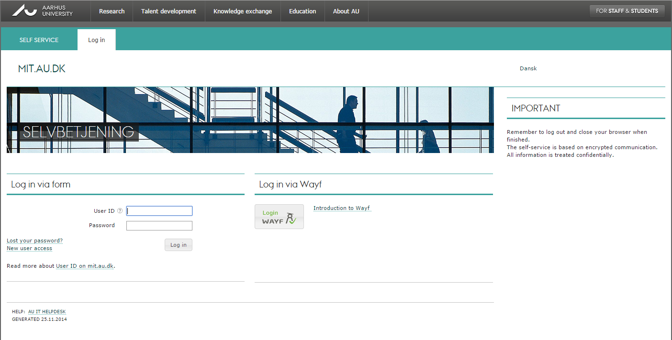
Type NemId in the text input field and select NemId:
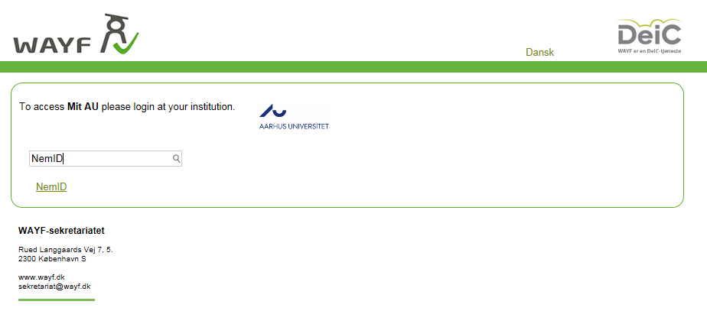
You may be asked to run a Java plugin – click Run and log on with your NemID code card:
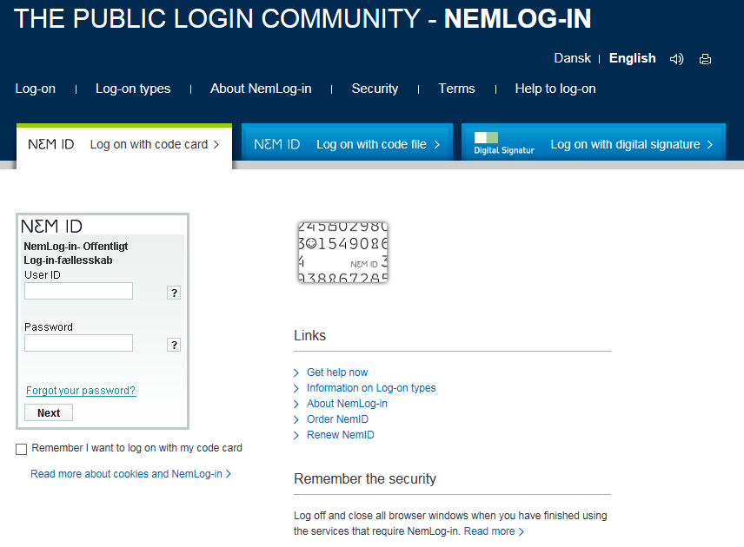
Next you will be logged on to AU Self Service.
Change your password – you will have to use that to log in to WISEflow with WAYF:
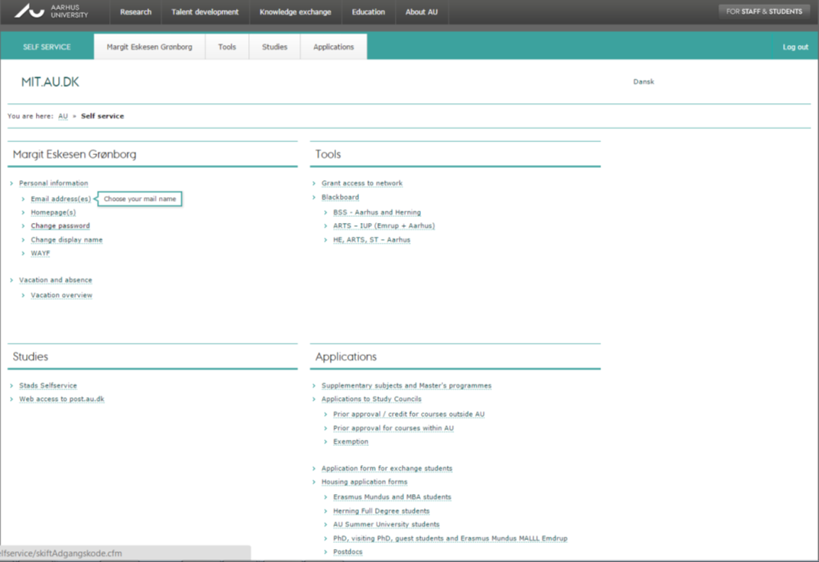
Now close all your browser windows and restart your browser – or open a different browser, e.g. Firefox or Chrome.
Go to http://au.wiseflow.dk and log on using WAYF or NemID.

